**Scema Design:**

**Create Database**

**CREATE DATABASE Institute_Management_System;**

**USE Institute_Management_System;**

**Create Users Table**

**CREATE TABLE Users (**

user_id,

username,

password_hash,

email,

role,

created_at,

updated_at,

is_active

**);**

**Create Students Table**

**CREATE TABLE Students (**

student_id,

user_id,

name,

contact_number,

address,

enrollment_date,

updated_at

**);**

**Create Faculty Table**

**CREATE TABLE Faculty (**

faculty_id,

user_id,

name,

contact_number,

department,

updated_at

**);**

**Create Courses Table**

**CREATE TABLE Courses (**

course_id,

course_code,

course_name,

description,

credits,

faculty_id,

semester,

year

**);**

**Create Student_Courses Table**

**CREATE TABLE Student_Courses (**

student_course_id,

student_id,

course_id,

enrollment_date,

status

**);**

**Create Attendance Table**

**CREATE TABLE Attendance (**

attendance_id,

student_id,

course_id,

date,

status,

remarks

**);**

**Create Grades Table**

**CREATE TABLE Grades (**

grade_id,

student_id,

course_id,

grade,

remarks,

date_assigned

**);**

**Create Examinations Table**

**CREATE TABLE Examinations (**

exam_id,

course_id,

exam_date,

duration,

total_marks,

exam_type

**);**

**Create Fee_Structure Table**

**CREATE TABLE Fee_Structure (**

fee_structure_id,

fee_type,

amount,

description

**);**

**Create Fee_Payments Table**

**CREATE TABLE Fee_Payments (**

payment_id,

student_id,

fee_structure_id,

payment_date,

amount_paid,

status,

payment_method

**);**

**Create a Timetable Table**

**CREATE TABLE Timetable (**

timetable_id,

course_id,

faculty_id,

room,

day,

start_time,

end_time

**);**

**Create Notifications Table**

**CREATE TABLE Notifications (**

notification_id,

user_id,

message,

created_at,

expiry_date,

is_read

**);**

**E-R Diagram:** 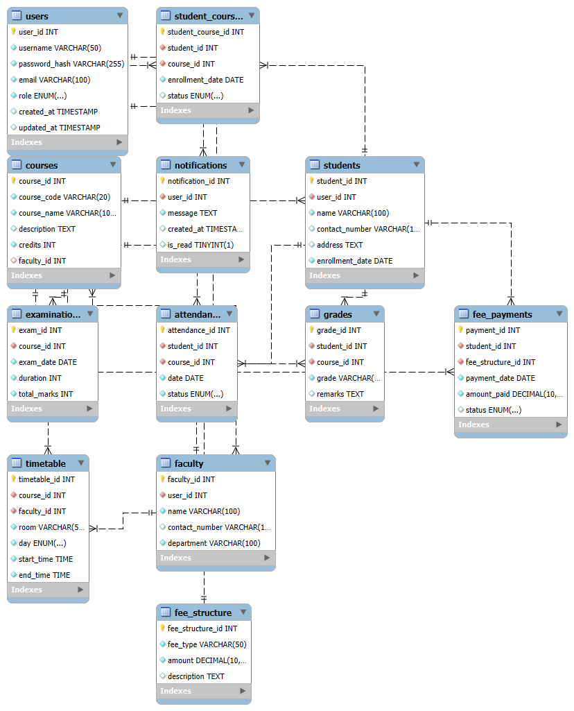

**Normal Froms:**

**1st Normal Form (1NF)**

All tables are already in 1NF because:

* Each table has a primary key.
* All attributes are atomic.

**2nd Normal Form (2NF)**

No partial dependencies exist, so all tables are in 2NF. Below are the tables:

1. **Users**

| **user_id** | **username** | **password_hash** | **email** | **role** | **created_at** | **updated_at** |
| --- | --- | --- | --- | --- | --- | --- |
| 1 | admin01 | hashed_password_1 | [admin@example.com](mailto:admin@example.com) | admin | 2023-09-01 10:00:00 | 2023-09-01 10:00:00 |
| 2 | faculty01 | hashed_password_2 | [faculty@example.com](mailto:faculty@example.com) | faculty | 2023-09-01 10:00:00 | 2023-09-01 10:00:00 |
| 3 | student01 | hashed_password_3 | [student@example.com](mailto:student@example.com) | student | 2023-09-01 10:00:00 | 2023-09-01 10:00:00 |

1. **Students**

| **student_id** | **user_id** | **name** | **contact_number** | **address** | **enrollment_date** |
| --- | --- | --- | --- | --- | --- |
| 1 | 3 | John Doe | 1234567890 | 123 Street, City | 2023-09-01 |

1. **Faculty**

| **faculty_id** | **user_id** | **name** | **contact_number** | **department** |
| --- | --- | --- | --- | --- |
| 1 | 2 | Dr. Smith | 0987654321 | Computer Science |

1. **Courses**

| **course_id** | **course_code** | **course_name** | **description** | **credits** | **faculty_id** |
| --- | --- | --- | --- | --- | --- |
| 1 | CS101 | Introduction to Programming | Basic programming concepts | 3 | 1 |
| 2 | CS102 | Data Structures | Fundamentals of data structures | 4 | 1 |

1. **Student_Courses**

| **student_course_id** | **student_id** | **course_id** | **enrollment_date** | **status** |
| --- | --- | --- | --- | --- |
| 1 | 1 | 1 | 2023-09-05 | enrolled |

1. **Attendance**

| **attendance_id** | **student_id** | **course_id** | **date** | **status** |
| --- | --- | --- | --- | --- |
| 1 | 1 | 1 | 2023-09-06 | present |

1. **Grades**

| **grade_id** | **student_id** | **course_id** | **grade** | **remarks** |
| --- | --- | --- | --- | --- |
| 1 | 1 | 1 | A | Excellent performance |

1. **Examinations**

| **exam_id** | **course_id** | **exam_date** | **duration** | **total_marks** |
| --- | --- | --- | --- | --- |
| 1 | 1 | 2023-12-01 | 120 | 100 |

1. **Fee_Structure**

| **fee_structure_id** | **fee_type** | **amount** | **description** |
| --- | --- | --- | --- |
| 1 | Tuition | 5000.00 | Semester tuition fee |
| 2 | Library | 500.00 | Library maintenance fee |

1. **Fee_Payments**

| **payment_id** | **student_id** | **fee_structure_id** | **payment_date** | **amount_paid** | **status** |
| --- | --- | --- | --- | --- | --- |
| 1 | 1 | 1 | 2023-09-10 | 5000.00 | paid |

1. **Timetable**

| **timetable_id** | **course_id** | **faculty_id** | **room** | **day** | **start_time** | **end_time** |
| --- | --- | --- | --- | --- | --- | --- |
| 1 | 1 | 1 | Room 101 | Monday | 09:00:00 | 10:30:00 |

1. **Notifications**

| **notification_id** | **user_id** | **message** | **created_at** | **is_read** |
| --- | --- | --- | --- | --- |
| 1 | 3 | Welcome to the Institute! | 2023-09-01 10:00:00 | FALSE |

**3rd Normal Form (3NF)**

All tables are already in 3NF since there are no transitive dependencies.

**Boyce-Codd Normal Form (BCNF)**

All tables are already in BCNF since there are no functional dependencies that violate the rules.